**Summary of the project phases**

The **project life cycle** is the path for your project from start to finish. Each project phase builds toward the subsequent phase and helps to create a structure for the project. To recap, the main phases of the project life cycle are: initiating the project, making a plan, executing and completing tasks, and closing the project.

In this reading, we will summarize each phase of the project life cycle.

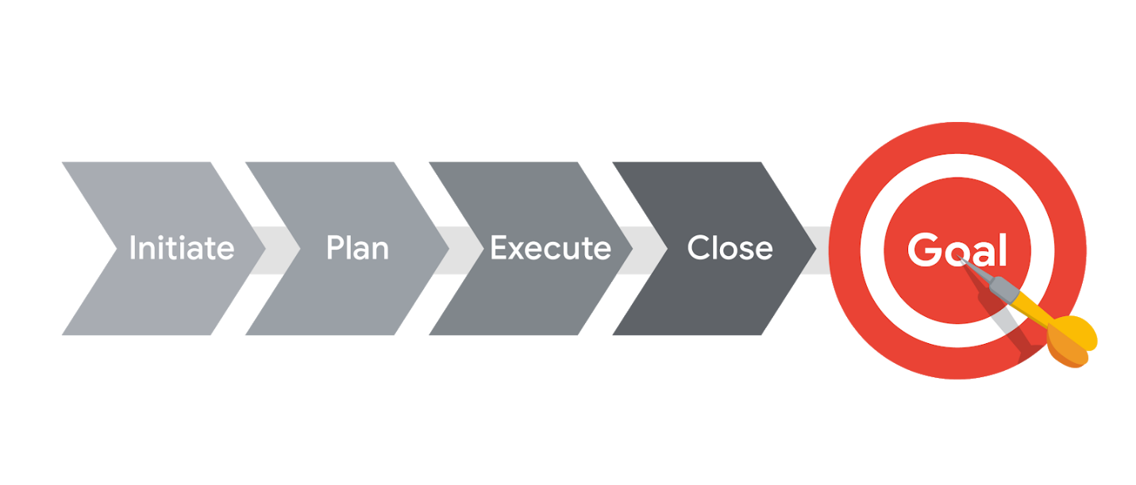

**The project life cycle**

**Initiate the project**

In this phase, ask questions to help set the foundation for the project, such as:

* Who are the stakeholders?
* What are the client’s or customer’s goals?
* What is the purpose and mission of the project?
* What are the measurable objectives for the team?
* What is the project trying to improve?
* When does this project need to be completed?
* What skills and resources will the project require?
* What will the project cost? What are the benefits?

**Make a plan**

In this phase, make a plan to get your project from start to finish.

* Create a detailed project plan. What are the major milestones? What tasks or deliverables make up each milestone?
* Build out the schedule so you can properly manage the resources, budget, materials, and timeline. Here, you will create an itemized budget.

**Execute the project**

In this phase, put all of your hard work from the first two phases into action.

* Monitor your project team as they complete project tasks.
* Break down any barriers that would slow or stop the team from completing tasks.
* Help keep the team aware of schedule and deliverable expectations.
* Address weaknesses in your process or examine places where your team may need additional training to meet the project’s goals.
* Adapt to changes in the project as they arise.

**Close the project**

In this phase, close out the project.

* Identify that your team has completed all of the requested outcomes.
* Release your team so they can support other projects within the company.
* Take time with your team to celebrate your successes!
* Pass off all remaining deliverables and get stakeholder approval.
* Document the lessons you and your team learned during the project.
* Reflect on ways to improve in the future.

**Key takeaway**

Each phase of the project life cycle has its own significance and reason for existing. By following the project life cycle, you’re ensuring that you are:

* Capturing the expectations of your customer
* Setting your project up for success with a plan
* Executing project tasks and addressing any issues that arise
* Closing out your project to capture any lessons learned

As you continue through this course, we will walk through each project phase in more detail.